1.8 PUZZLE PROBLEM

print("Keerthi")
print(192312495)
print("1.8 PUZZLE PROBLEM")
print()
# Goal State
goal = [1, 2, 3, 4, 5, 6, 7, 8, 0]

# Initial State (given in the code)
state = [1, 2, 3, 4, 5, 6, 0, 7, 8]

# Check whether the goal state is reached
if state == goal:
print("Goal State Reached!")
else:
count = 0
for i in range(9):
if state[i] != 0 and state[i] != goal[i]:
count += 1

print("Misplaced Tiles =", count)

# Display Initial State
print("\nInitial State:")
for i in range(0, 9, 3):
print(state[i:i+3])

# Display Goal State
print("\nGoal State:")
for i in range(0, 9, 3):
print(goal[i:i+3])
OUTPUT
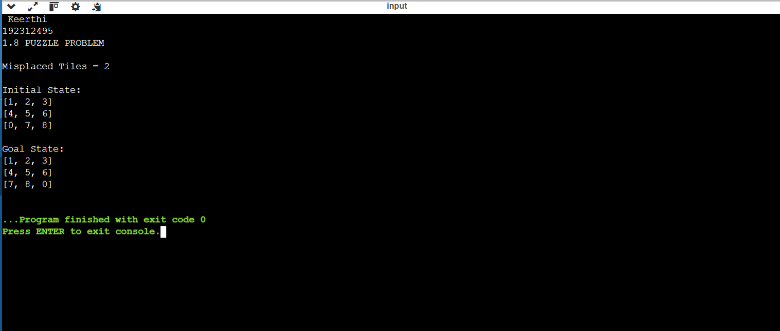

2.8 QUEEN PROBLEM

print("keerthi")
print(192312495)
print("2.8 QUEEN PROBLEM")
print()

# 8 Queen Problem using Backtracking

N = int(input("Enter the number of queens: "))

x = [-1] * N

def safe(r, c):
for i in range(c):
if x[i] == r or abs(x[i] - r) == abs(i - c):
return False
return True

def queen(c):
if c == N:
print("\nSolution:")
for i in range(N):
print(x[i], end=" ")
print()
return True

for r in range(N):
if safe(r, c):
x[c] = r
if queen(c + 1):
return True
x[c] = -1 # Backtrack

return False

if not queen(0):
print("No Solution")

OUTPUT:
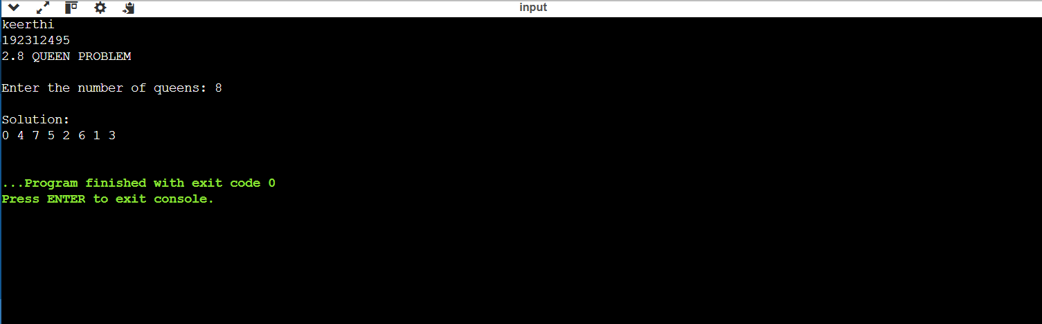

3. WATER JUG PROBLEM

print("Keerthi")
print(192312495)
print("3.WATER JUG PROBLEM")
print()

# Water Jug Problem

j1 = int(input("Enter capacity of Jug 1: "))
j2 = int(input("Enter capacity of Jug 2: "))
target = int(input("Enter target amount: "))

a = 0
b = 0

print("\nSteps:")

while b != target:
print("Jug1 =", a, "Jug2 =", b)

if a == 0:
a = j1 # Fill Jug 1

elif b == j2:
b = 0 # Empty Jug 2

else:
t = min(a, j2 - b)
a = a - t # Pour Jug 1 into Jug 2
b = b + t

print("Jug1 =", a, "Jug2 =", b)
print("Target Reached!")

OUTPUT:
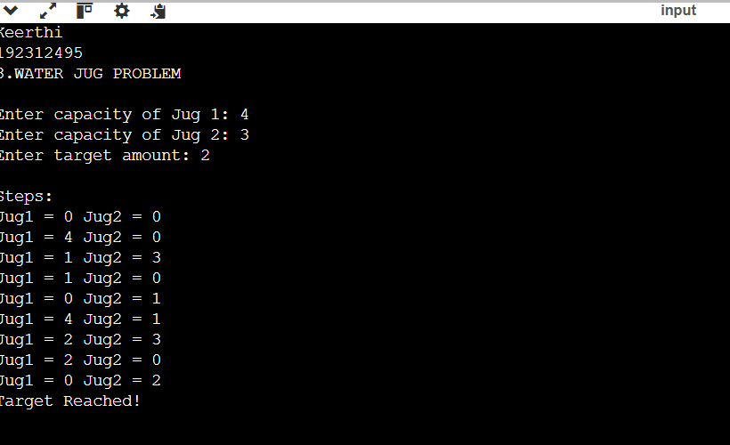
4.VACUUM CLEANER PROBLEM

print("Keerthi")
print(192312495)
print("4.VACUUM CLEANER PROBLEM")
print()

# Vacuum Cleaner Problem

A = input("Enter Room A status (Dirty/Clean): ")
B = input("Enter Room B status (Dirty/Clean): ")

print("\nInitial State")
print("Room A =", A)
print("Room B =", B)

print("\nVacuum starts at Room A")

if A.lower() == "dirty":
print("Room A is Dirty")
print("Cleaning Room A...")
A = "Clean"
else:
print("Room A is already Clean")

print("\nMove to Room B")

if B.lower() == "dirty":
print("Room B is Dirty")
print("Cleaning Room B...")
B = "Clean"
else:
print("Room B is already Clean")

print("\nFinal State")
print("Room A =", A)
print("Room B =", B)

print("\nAll rooms are clean.")
OUTPUT:
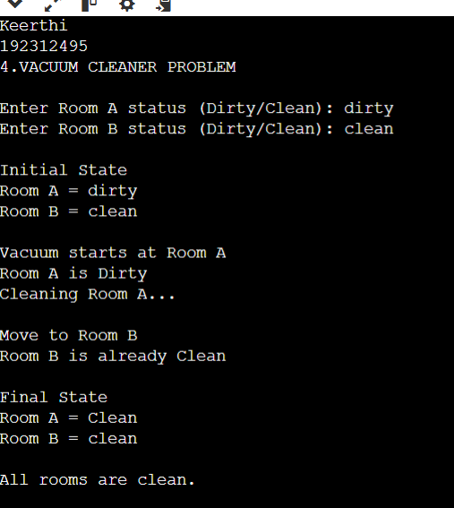
5. BREADTH FIRST SEARCH (BFS)

print("Keerthi")
print(192312495)
print("5.BREADTH FIRST SEARCH (BFS)")
print()

# Breadth First Search (BFS)

visited = []
queue = []

graph = {}

n = int(input("Enter number of vertices: "))

for i in range(n):
vertex = input("Enter vertex: ")
neighbors = input("Enter adjacent vertices (space separated): ").split()
graph[vertex] = neighbors

def bfs(start):
visited.append(start)
queue.append(start)

while queue:
node = queue.pop(0)
print(node, end=" ")

for i in graph[node]:
if i not in visited:
visited.append(i)
queue.append(i)

start = input("\nEnter starting vertex: ")

print("BFS Traversal:")
bfs(start)
OUTPUT:
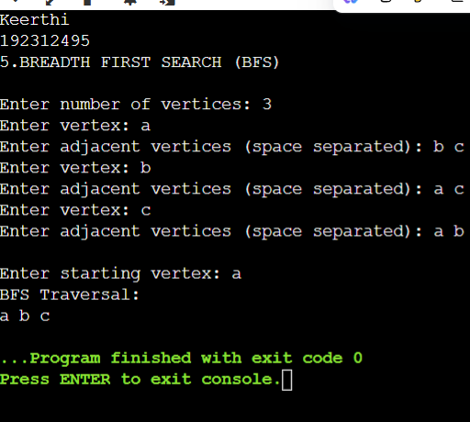
6.DEPTH FIRST SEARCH (DFS)

print("Keerthi")
print(192312495)
print("6.DEPTH FIRST SEARCH (DFS)")
print()

# Depth First Search (DFS)

visited = []
graph = {}

n = int(input("Enter number of vertices: "))

for i in range(n):
vertex = input("Enter vertex: ")
neighbors = input("Enter adjacent vertices (space separated): ").split()
graph[vertex] = neighbors

def dfs(node):
if node not in visited:
print(node, end=" ")
visited.append(node)

for i in graph[node]:
dfs(i)

start = input("\nEnter starting vertex: ")

print("\nDFS Traversal:")
dfs(start)
OUTPUT:
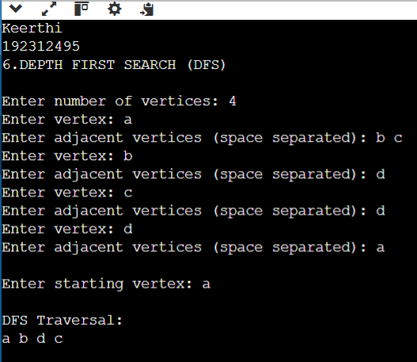

7. MISSIONARIES AND CANNIBALS PROBLEM

print("Keerthi")
print(192312495)
print("7.MISSIONARIES AND CANNIBALS PROBLEM")
print()

from collections import deque

# Initial state: (Missionaries, Cannibals, Boat Position)
# Boat Position: 0 = Left Bank, 1 = Right Bank
q = deque([((3, 3, 0), [])])

# Possible boat moves
moves = [(1, 0), (2, 0), (0, 1), (0, 2), (1, 1)]

seen = set()

while q:
(m, c, b), path = q.popleft()

if (m, c, b) in seen:
continue

seen.add((m, c, b))

# Goal state
if (m, c, b) == (0, 0, 1):
solution = path + [(m, c, b)]

print("Solution Path:")
for state in solution:
print(state)
break

# Generate next possible states
for x, y in moves:
if b == 0: # Boat moves from left to right
nm = m - x
nc = c - y
else: # Boat moves from right to left
nm = m + x
nc = c + y

# Check if state is valid
if 0 <= nm <= 3 and 0 <= nc <= 3:
# Missionaries should never be outnumbered by cannibals
if (nm == 0 or nm >= nc) and ((3 - nm) == 0 or (3 - nm) >= (3 - nc)):
q.append(((nm, nc, 1 - b), path + [(m, c, b)]))

OUTPUT:
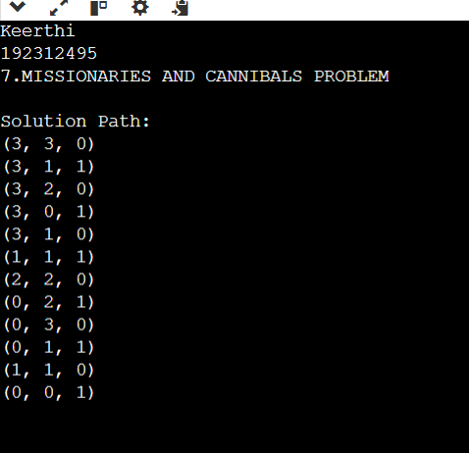

8. TRAVELLING SALESMAN PROBLEM

print("Keerthi")
print(192312495)
print("8.TRAVELLING SALESMAN PROBLEM")
print()

from itertools import permutations

d = [[0,10,15,20],
[10,0,35,25],
[15,35,0,30],
[20,25,30,0]]

cost = 999
path = ()

for p in permutations([1,2,3]):
c = d[0][p[0]] + d[p[0]][p[1]] + d[p[1]][p[2]] + d[p[2]][0]
if c < cost:
cost = c
path = (0,) + p + (0,)

print("Shortest Path:", path)
print("Minimum Cost:", cost)
OUTPUT:
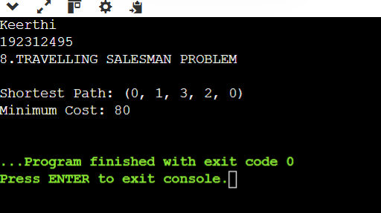

9. CRYPT ARITHMETIC PROBLEM

print("Keerthi")
print(192312495)
print("9.CRYPT ARITHMETIC PROBLEM")
print()

from itertools import permutations

# Assign unique digits to S,E,N,D,M,O,R,Y
for p in permutations(range(10), 8):
S, E, N, D, M, O, R, Y = p

# S and M cannot be zero (leading digits)
if S != 0 and M != 0:

send = 1000*S + 100*E + 10*N + D
more = 1000*M + 100*O + 10*R + E
money = 10000*M + 1000*O + 100*N + 10*E + Y

# Check equation
if send + more == money:
print("SEND =", send)
print("MORE =", more)
print("MONEY =", money)

print("\nSolution:")
print("S =", S)
print("E =", E)
print("N =", N)
print("D =", D)
print("M =", M)
print("O =", O)
print("R =", R)
print("Y =", Y)
break
OUTPUT:
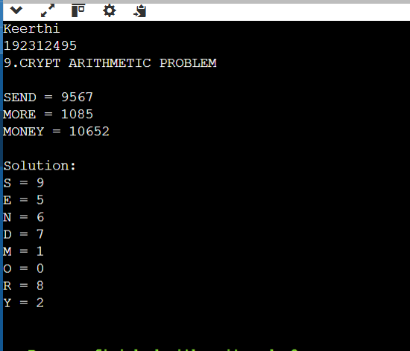

10. A* ALGORITHM

print("Keerthi")
print(192312495)
print("10.A* ALGORITHM")
print()

# A* Algorithm Implementation

graph = {}

n = int(input("Enter number of nodes: "))

# Input graph
for i in range(n):
node = input("Node: ")
graph[node] = {}

e = int(input("Edges from " + node + ": "))

for j in range(e):
v = input("Connected node: ")
c = int(input("Cost: "))
graph[node][v] = c

# Input heuristic values
h = {}

for i in graph:
h[i] = int(input("Heuristic of " + i + ": "))

start = input("Start node: ")
goal = input("Goal node: ")

# A* variables
open_list = [start]
cost = {start: 0}
parent = {start: None}

while open_list:

# Select node with minimum f(n)=g(n)+h(n)
x = min(open_list, key=lambda i: cost[i] + h[i])

open_list.remove(x)

# Goal reached
if x == goal:
path = []

while x is not None:
path.append(x)
x = parent[x]

print("Shortest Path:", path[::-1])
print("Total Cost:", cost[goal])
break

# Explore neighbours
for y in graph[x]:

g = cost[x] + graph[x][y]

if y not in cost or g < cost[y]:
cost[y] = g
parent[y] = x

if y not in open_list:
open_list.append(y)

else:
print("No path found")
OUTPUT:
